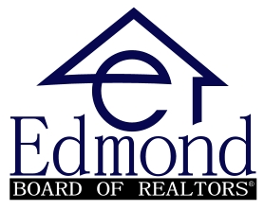
Grant Request Application - 2026
The Edmond Board of REALTORS® has several fundraisers throughout the year to raise funds for our local communities. Monies raised support scholarships, community projects and grants to nonprofit organizations such as yours. We invite you to take advantage of this opportunity by submitting this application.
Fund requests must clearly serve the Edmond, Guthrie or Deer Creek communities. We prefer to fund needed equipment, development of new programs and support of cultural, educational, social and civic programs. We will not discriminate for or against any applicant on the basis of race, religion, creed or political affiliation. Our Community Donation Task Force and Board of Directors will be responsible for selecting the organization(s) that receive the funds.
Applications are being accepted through April 30, 2026 for funding awarded in the 2026. Amounts may vary year to year based on funds raised.

1. Name of Proposed Program / Project: ___________________________________________________________________________

2. Applicant Name: ____________________________________________________________________________

3. Contact Name/Address: ____________________________________________________________________________

Phone:___________________________ Email:_______________________________

4. Organization’s mission statement:

5. Please give a brief description of your organization’s activities, and the impact they have on the community.

6. Please briefly describe an unmet need or project within your agency that would benefit from this grant.

7. Please attach proof of your 501 (c) 3 status.

Submit application to ae@edmondrealtors.com or mail by March 30, 2026

